**Elements of AI - Programming Assignment 1 – Read Me**

*Ganesh Nagarajan (gnagaraj) & Siddharth Jayasankar (sidjayas)*

**Program:**

The program is contained in the Python file “PA1_BFS_DFS_ID.py”

**Map Input:**

The Name of the CSV file needs to be specified at line 5 of the program.

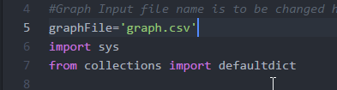

The Map input for this program should be a CSV file in the below format.

<Source>, <Destination>, <Distance>

Also, The program assumes there is a windows based new line, ie there is a Carriage Return and Line feed (“\r\n”). An example view of the file (in notepad ++ with whitespaces view) is shown as follows,



Example:

Oradea, Zerind, 71

*Note:* The program considers each edge to be a 2-way edge hence the return path need not be present in the input file. In case, if there are two entries representing front and back edge, line 22 must be commented, else the program will return twice the actual distance.

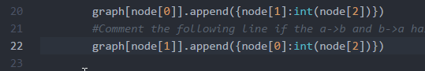

**Program Execution:**

The Program takes 3 parameters from the command line. The parameters should be specified in the in the below specified manner and order.

<source> <destination> <BFS/DFS/ID>

Following are the three test cases that were requested:

1. Arad to Bucharest:

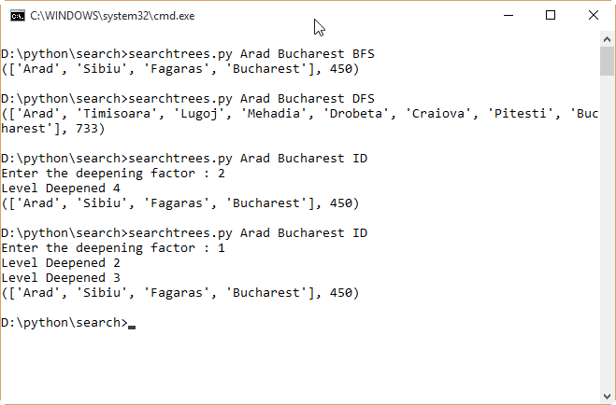

Notice that Iterative deepening requests for the deepening factor, this is the level up to which iterative deepening must pursue from a single branch before it decides give up and search the next branch.

1. Sibiu and Eforie:

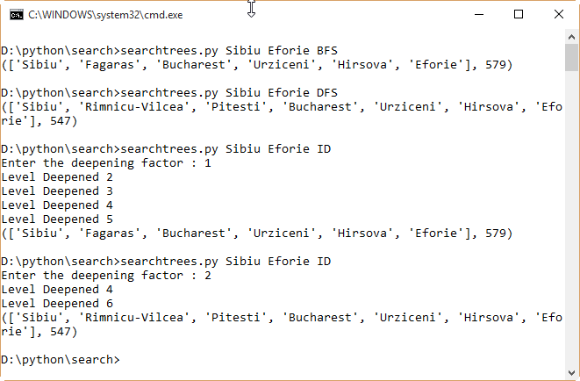

Notice that ID gives two results based on the depth level. One corresponds to result that is reached by BFS, other by DFS.

1. Drobeta and Fagaras:

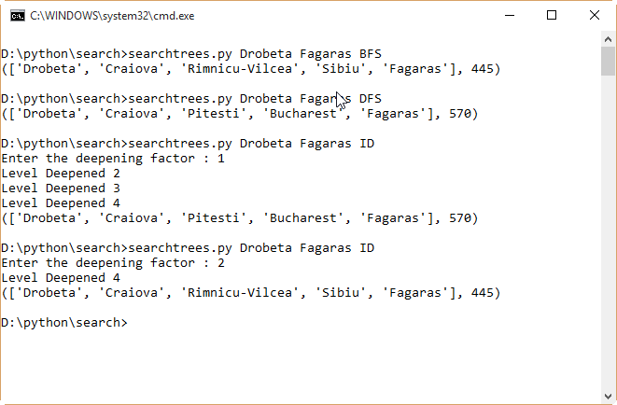

As with the example before, with this use case ID gives two different results with different depth levels.